Final Year Project(GRP-15)
Content Based Recommendation App

Arnab Sadhukhan(11)
Abhishek Kumar(12)
Raushan Kumar(13)
Abhisikt Jha((14)
Nitish Kumar(15)
Saptak Dutta(16)
Contents
1 Introduction
2 Related Work
3 Application Domain
4 On Purposed Thought
5 Conclusion

Figure 1: Movie recommendation app

Abstract
Recommendation systems have become extremely common in recent years.The system recommends personalised sets of videos to users based on their activity on the site. It is a software tool and techniques that provide suggestions based on the customer's taste to discover new appropriate things for them by filtering personalised information based on the user's preferences from a large volume of information. Collaborative Filtering (CF) is a method of making automatic predictions about the interests of customers by collecting information from a number of other customers.CHARM algorithm is one of the frequent patterns finding algorithm which is capable to handle huge dataset, unlike all previous association mining algorithms which do not support huge dataset

INTRODUCTION- Recommendation system has been seen to be very useful for user to select an item amongst many. It produces a ranked list of items on which a user might be interested, in the context of his current choice of an item. It helps the user to address the problem of information overload and finds the relevant objects for user. Recommendation system has been built for movies, book, communities, news, articles etc. There are two main approaches to build a recommendation system - collaborative filtering and content based . Collaborative filtering recommenders use the opinions of other users to predict the value of items for each user in the community. Whereas content based recommendation systems recommend on basis of the content similarity between objects. A hybrid recommender system also can be built by combining collaborative filtering and content based system.
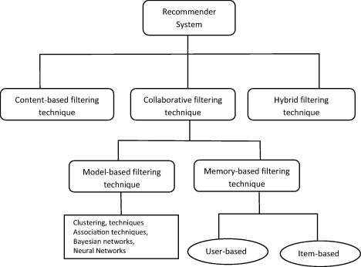
Content based recommendation systems are very much useful when there is no or very less user data available. In that case depending on the similarity between the items the system recommends. The similarity of the content of the items is measured. To find this similarity various machine learning techniques (supervised or unsupervised) can be applied.

Related works
Recommender system is defined as a decision making strategy for users under complex information environments . Also, recommender system was defined from the perspective of E-commerce as a tool that helps users search through records of knowledge which is related to users’ interest and preference . Recommender system was defined as a means of assisting and augmenting the social process of using recommendations of others to make choices when there is no sufficient personal knowledge or experience of the alternatives. Recommender systems handle the problem of information overload that users normally encounter by providing them with personalized, exclusive content and service recommendations.
GroupLens is a news-based architecture which employed collaborative methods in assisting users to locate articles from massive news database . Ringo is an online social information filtering system that uses collaborative filtering to build users profile based on their ratings on music albums . Amazon uses topic diversification algorithms to improve its recommendation . A simple and straightforward method for combining content-based and collaborative filtering was proposed by Cunningham et al. [27]. A music recommendation system which combined tagging information, play counts and social relations was proposed in Konstas et al. Also a Bayesian mixed-effects model that integrates user ratings, user and item features in a single unified framework was proposed by Condiff et al.

APPLICATION DOMAIN
Recommendation systems have been widely used in many Internet activities and it is worth mentioning some examples of the current actual uses of Recommendation systems . However, we will mention some main sectors that use one or more techniques of Recommendation systems .
- E-COMMERCE- Examples of e-commerce sites which used Recommendation systems : Amazon.com, barnesnoble.com and CdNow.com
- WEB PAGES- Example of search engines which used RS: – Mi Yahoo! <http://my.yahoo.com>,
–Google <www.google.com/preferences>
- NEWS- Here are some examples of news recommenders:
-Net perceptions <www.netperceptions.com>,
-GroupLens <www.cs.umn.edu/Research/>,
-Le Monde newspaper <www.lemonde.fr>.
- CENSORSHIP SYSTEMS- RSs are used in the sector of the protection, mainly,
at the following domains:
– Kids and children protection from accessing
undesirable material on the internet. Example of
such system: Cyberpatrol.com.
– Prevent the citizens from exploring some Web sites;
which some governments already did due to many
reasons.
- Movies- Netfix ,Amazon prime etc.

OUR APPROACH :
We will develop an application in which user can maintain a catalogue of content they consume. User can also rate the contents . The application will recommend them similar content based on their rating and details of contents. For example, if a user watched a SRK movie and rated it 4/5 stars. Then, application will suggest them movies, songs, etc. of same genres or a movie starring SRK.

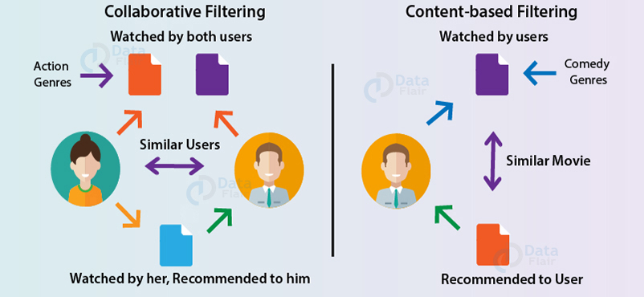

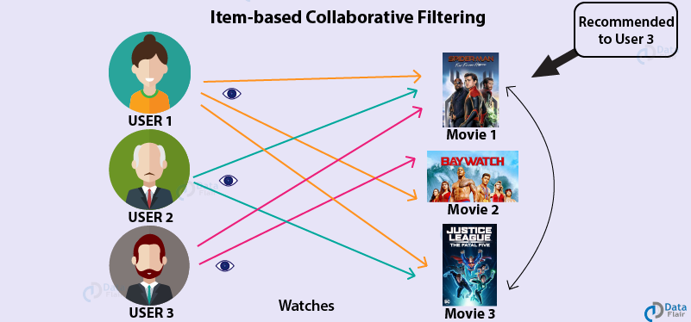

Conclusion
Recommender systems open new opportunities of retrieving personalized information on the Internet. Recommendation Systems are the most popular type of machine learning applications that are used in all sectors. They are an improvement over the traditional classification algorithms as they can take many classes of input and provide similarity ranking based algorithms to provide the user with accurate results. These recommendation systems have evolved over time and have incorporated many advanced machine learning techniques to provide the users with the content that they want.. It also helps to alleviate the problem of information overload which is a very common phenomenon with information retrieval systems and enables users to have access to products and services which are not readily available to users on the system.

References
[1] Adomavicius G, Tuzhilin A. Toward the next generation of recommender systems: a survey of the state-of-the-art and possible extensions[J]. IEEE Transactions on Knowledge and Data Engineering, 17(6): 734-749, 2005
[2] Park D H, Kim H K, Choi I Y, et al. A literature review andclassification of recommender systems research[J]. ExpertSystems with Applications, 39(11): 10059-10072, 2012
[3] Lecuny, Bengio Y, Hinton G. Deeplearning. Nature, 521(7553): 436-444, 2015
[4] Yu-xin, PENG, Wen-wu, et al. Cross-media analysis and reasoning: advances and directions[J]. Frontiers of Information Technology & Electronic Engineering, 18(1):44-57, 2017
[5] Covington P, Adams J, Sargin E. Deep Neural Networks for YouTube Recommendations[C]// ACM Conference on Recommender Systems. ACM, 2016:191-198.
[6] Park D H, Kim H K, Choi I Y, et al. A literature review andclassification of recommender systems research[J]. ExpertSystems with Applications, 39(11): 10059-10072, 2012
[7] Jing L. Automatic Image Annotation Based on Concept Indexing[J]. Journal of Computer Research & Development, 44(3):452, 2007.
[8] Aciar S, Zhang D, Simoff S, et al. Recommender System Based on Consumer Product Reviews[C]// IEEE/WIC/ACM International Conference on Web Intelligence. IEEE Computer Society, 2007:719-723.
[9] Tintarev N, Masthoff J. A Survey of Explanations in Recommender Systems[C]// IEEE, International Conference on Data Engineering Workshop. IEEE, 2007:801-810.

